Supplementary Material
Table SM1. Radon statistics from hourly values (in Bq m⁻³) for each season for El Carmen, La Rabida, Motril and Tarifa measurement stations: coverage (Cov. in %), maximum (Max.), 95th percentile (P95), 75th percentile (P75), average (Avg.), standard deviation (Std.), 50th percentile (P50) , 25th percentile (P25), 5th percentile (P5) and minimum (Min.).
Season | Station | Cov. | Max. | P95 | P75 | Avg. | Std. | P50 | P25 | P5 | Min.
Annual | El Carmen | 92.0 | 43.8 | 21.1 | 8.4 | 6.5 | 6.8 | 3.9 | 2.0 | 0.5 | 0.0
 | La Rabida | 82.7 | 47.8 | 17.9 | 8.7 | 6.2 | 5.7 | 4.2 | 2.2 | 0.7 | 0.0
 | Motril | 96.3 | 14.1 | 7.3 | 4.0 | 3.0 | 2.1 | 2.5 | 1.5 | 0.5 | 0.0
 | Tarifa | 96.0 | 23.2 | 7.9 | 3.7 | 3.0 | 2.5 | 2.3 | 1.4 | 0.3 | 0.0
Winter | El Carmen | 87.0 | 38.1 | 22.9 | 14.0 | 9.5 | 6.8 | 7.5 | 4.0 | 1.5 | 0.2
 | La Rabida | 85.9 | 34.1 | 22.1 | 14.4 | 10.6 | 6.2 | 9.8 | 5.6 | 2.4 | 0.2
 | Motril | 96.9 | 10.6 | 8.1 | 4.5 | 3.3 | 2.2 | 2.7 | 1.6 | 0.7 | 0.3
 | Tarifa | 98.8 | 19.6 | 8.5 | 4.4 | 3.5 | 2.6 | 2.7 | 1.8 | 0.7 | 0.0
Spring | El Carmen | 82.5 | 23.0 | 8.6 | 3.0 | 2.6 | 3.1 | 1.6 | 0.7 | 0.3 | 0.0
 | La Rabida | 66.1 | 16.3 | 7.7 | 3.4 | 2.7 | 2.4 | 2.0 | 1.1 | 0.3 | 0.0
 | Motril | 97.6 | 14.1 | 6.8 | 3.4 | 2.6 | 1.9 | 2.1 | 1.2 | 0.5 | 0.1
 | Tarifa | 90.2 | 14.7 | 7.1 | 3.1 | 2.5 | 2.2 | 2.0 | 1.1 | 0.0 | 0.0
Summer | El Carmen | 99.6 | 43.8 | 19.0 | 6.1 | 5.6 | 5.9 | 3.6 | 2.2 | 1.0 | 0.0
 | La Rabida | 84.1 | 35.9 | 11.4 | 5.1 | 4.2 | 3.9 | 3.1 | 1.9 | 0.7 | 0.0
 | Motril | 95.4 | 13.7 | 7.3 | 4.1 | 3.2 | 2.0 | 2.6 | 1.8 | 0.7 | 0.1
 | Tarifa | 96.3 | 18.7 | 8.0 | 4.0 | 3.1 | 2.5 | 2.5 | 1.6 | 0.4 | 0.1
Autumn | El Carmen | 98.8 | 43.4 | 25.6 | 10.8 | 8.0 | 8.0 | 4.8 | 2.6 | 0.7 | 0.2
 | La Rabida | 95.0 | 47.8 | 17.5 | 8.8 | 6.5 | 5.6 | 4.9 | 2.8 | 1.1 | 0.0
 | Motril | 95.1 | 11.6 | 7.5 | 4.0 | 3.0 | 2.1 | 2.4 | 1.5 | 0.5 | 0.0
 | Tarifa | 98.9 | 23.2 | 7.9 | 3.3 | 2.8 | 2.5 | 2.1 | 1.3 | 0.3 | 0.0

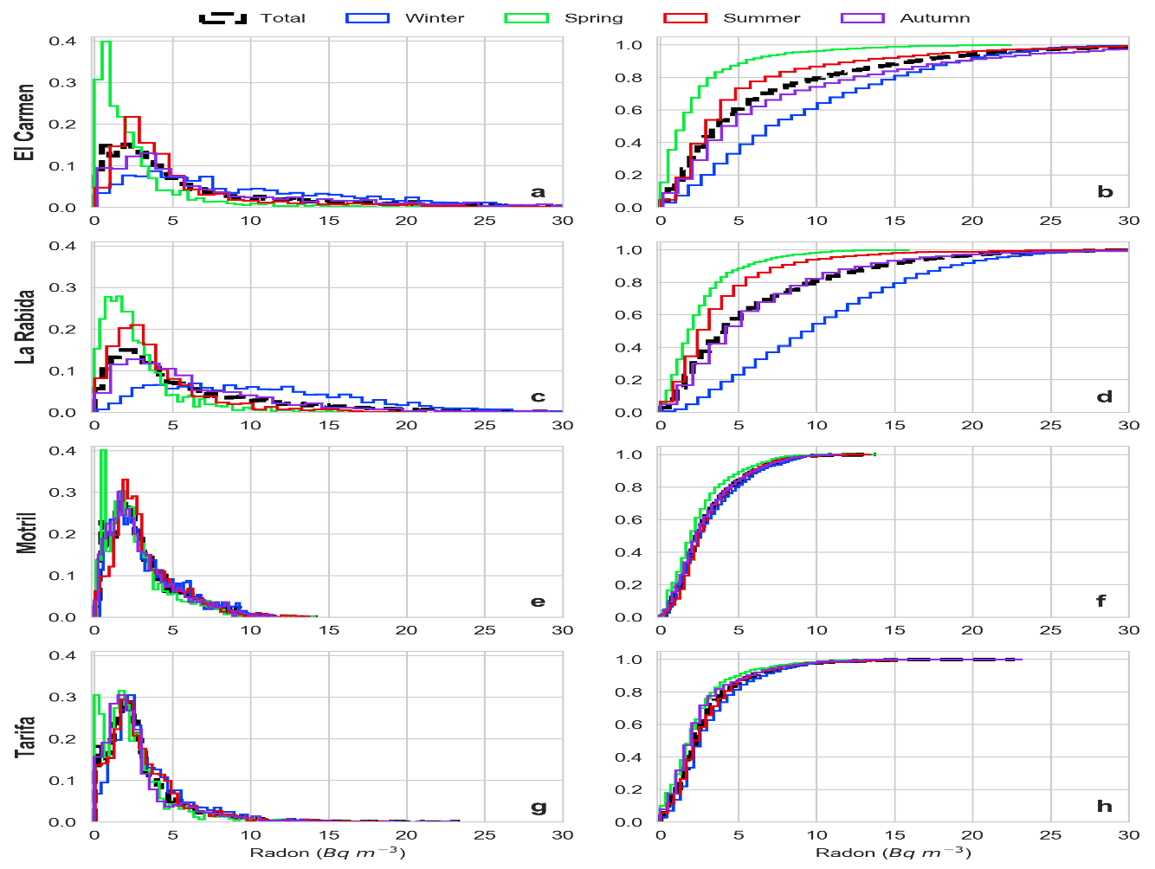
Fig. SM1. Normalized (left) and cumulative (right) probability density functions (PDF) for hourly radon concentrations at El Carmen (a, b), La Rabida (c, d), Motril (e, f) and Tarifa (g, h).

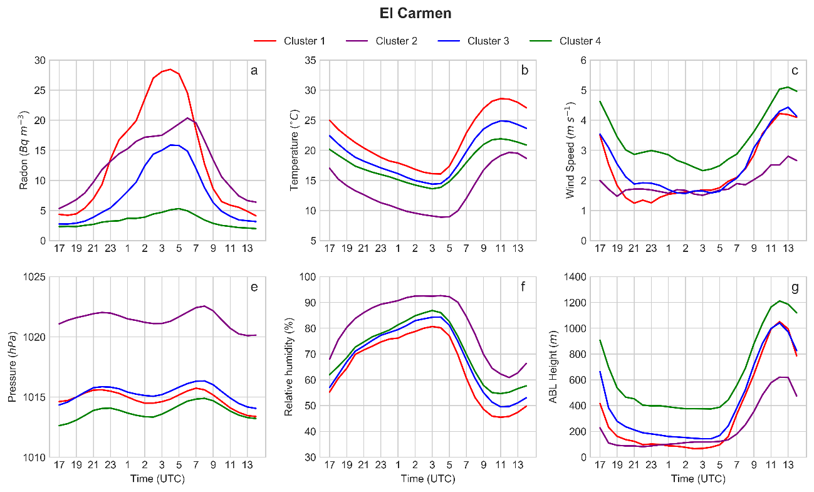
Fig. SM2. Radon, wind speed, temperature, relative humidity, pressure and PBL daily patterns associated to each clusters at El Carmen station.

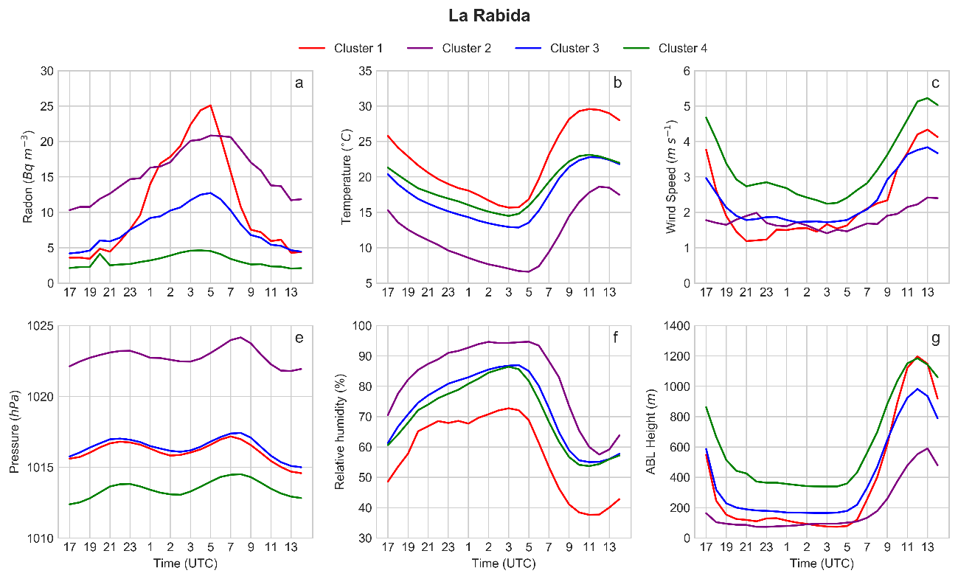
Fig. SM3. Radon, wind speed, temperature, relative humidity, pressure and PBL daily patterns associated to each clusters at La Rabida station.

Table SM2. Percentages of cluster distribution across seasons for El Carmen and La Rabida.
Station | Season | Cluster 1 | Cluster 2 | Cluster 3 | Cluster 4
El Carmen | Autumn | 20.78 | 12.99 | 25.97 | 40.26
 | Spring | 0.00 | 0.00 | 18.60 | 81.40
 | Summer | 9.68 | 1.61 | 25.81 | 62.90
 | Winter | 6.56 | 44.26 | 19.67 | 29.51
 | Year | 10.70 | 15.64 | 23.05 | 50.62
La  Rabida | Autumn | 11.69 | 3.90 | 41.56 | 42.86
 | Spring | 0.00 | 0.00 | 9.30 | 90.70
 | Summer | 6.45 | 0.00 | 16.13 | 77.42
 | Winter | 4.92 | 37.70 | 32.79 | 24.59
 | Year | 6.58 | 10.70 | 27.16 | 55.56

Table SM3. Number of “radon days” in cluster Cn that are also in cluster Rn. This number represents the amount of times the cluster assignation at the two stations coincided, i.e. radon behavior is similar at the two stations according to hierarchical clustering.
 |  | La Rabida
 | Cluster | R1 | R2 | R3 | R4
El Carmen | C1 | 13 | 3 | 7 | 3
 | C2 | 3 | 21 | 14 | 0
 | C3 | 0 | 2 | 37 | 17
 | C4 | 0 | 0 | 8 | 115

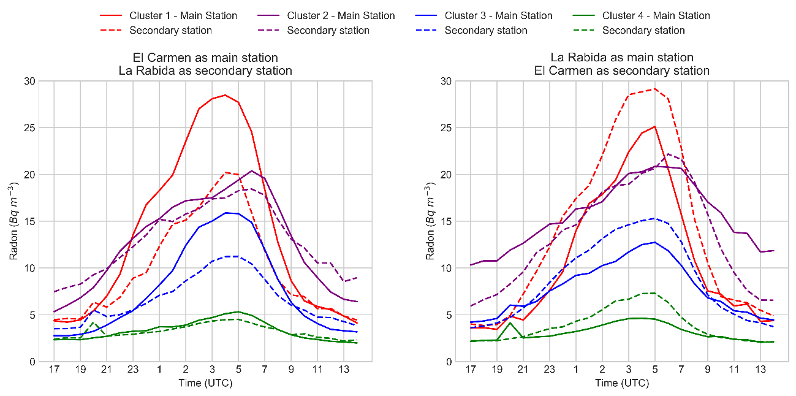
Fig. SM4. Daily average radon concentrations at both stations for days defined by El Carmen’s clusters (left) and defined by La Rabida’s clusters (right).

